PROJECT DEVELOPMENT PHASE
SPRINT-4
Team ID | PNT2022TMID36635
Team Members | Team lead: KUMMARI YASWANTH SAGAR  Member2: GOWTHAM R  Member3: MOHAMED ILYAS.M  Member4: MOHAN RAJ M  Member4: THATIPARTHI ROHITH
Project Name | Project – IOT-Based Safety Gadget for  Child Safety Monitoring and Notification

Project Diagrammatic Structure& Code:

- Parent mobile and wearable devices are connected with the help of cloud.
- If child was lost , the parent can access the location of child through the mobile application with the help of GSM module.
- Then, we can view the location of child with the help of mobile application.

CODE:
#Source code for GPS Location:
import phonenumbers
import opencage
import folium
import webbrowser
number = "+916385571249"
from phonenumbers import geocoder # is a function
par_number = phonenumbers.parse(number)
location = geocoder.description_for_number(par_number, "en")
print(location)
# to see the service provider name
from phonenumbers import carrier
service_par = phonenumbers.parse(number)
S_provider= carrier.name_for_number(service_par, "en")
print(S_provider)
# opencage is for to view the location.
from opencage.geocoder import OpenCageGeocode
key = "7098ec840cb24aa9a5c38cce49fb3b81"
geocoder = OpenCageGeocode(key)
query = str(location)
result = geocoder.geocode(query)
#print(result)
lat = result[0]['geometry']['lat']
lng = result[0]['geometry']['lng']
print(lat, lng)
####
mymap = folium.Map(location=[lat, lng], zoom_start=9)
folium.Marker([lat, lng], popup=location).add_to(mymap)
mymap.save("mylocation.html")
webbrowser.open_new_tab("mylocation.html")
#Source code for Mobile Call:
from twilio.rest import Client
account_SID = "AC89d677f42205372d8c7467d77f8124a5"
auth_token = "8d60fae39b28beaed14514b8d1cbf812"
client = Client(account_SID, auth_token)
call = client.calls.create(
from_='+12136932446',
to='+918438106497',
url='https://handler.twilio.com/twiml/EH7fcba664228739cbc7d1e51793d42420'
)
print(call.sid)
#Source code for Notification (Alert Message):

from twilio.rest import Client
account_SID = "AC89d677f42205372d8c7467d77f8124a5"
auth_token = "8d60fae39b28beaed14514b8d1cbf812"
client = Client(account_SID, auth_token)
message = client.messages.create(
from_ ='+12136932446',
to = '+918438106497',
body='Hi from Twilio'
)
print(message.sid)
OUTPUT:
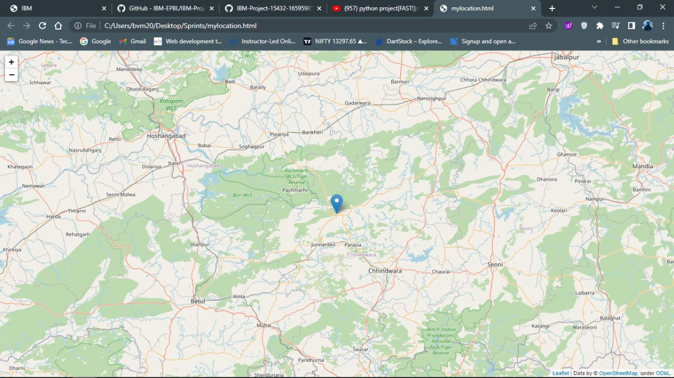

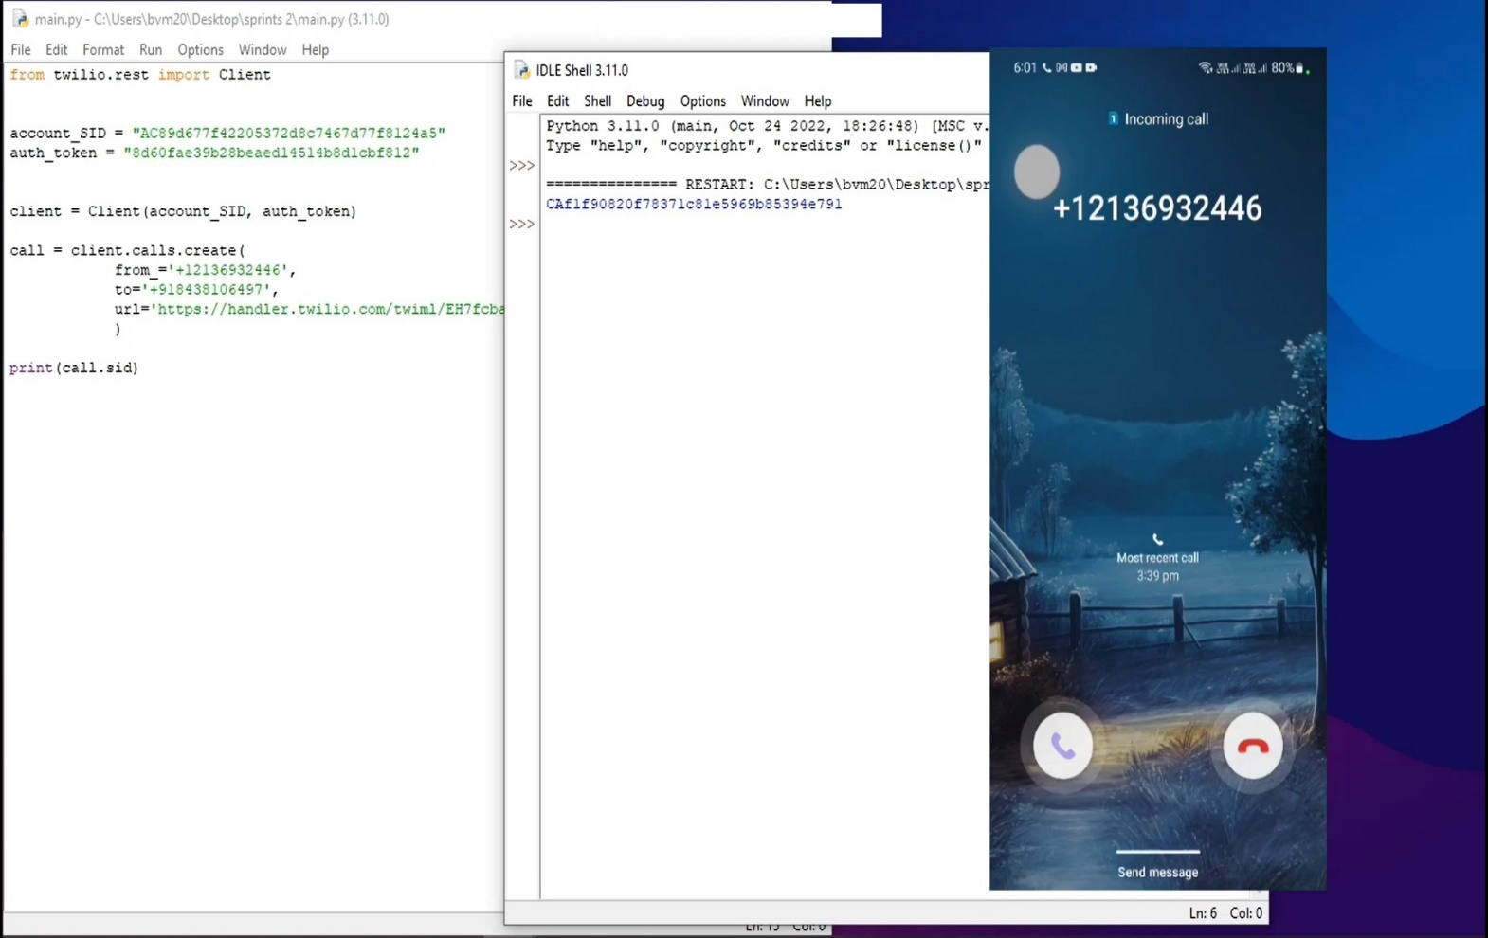

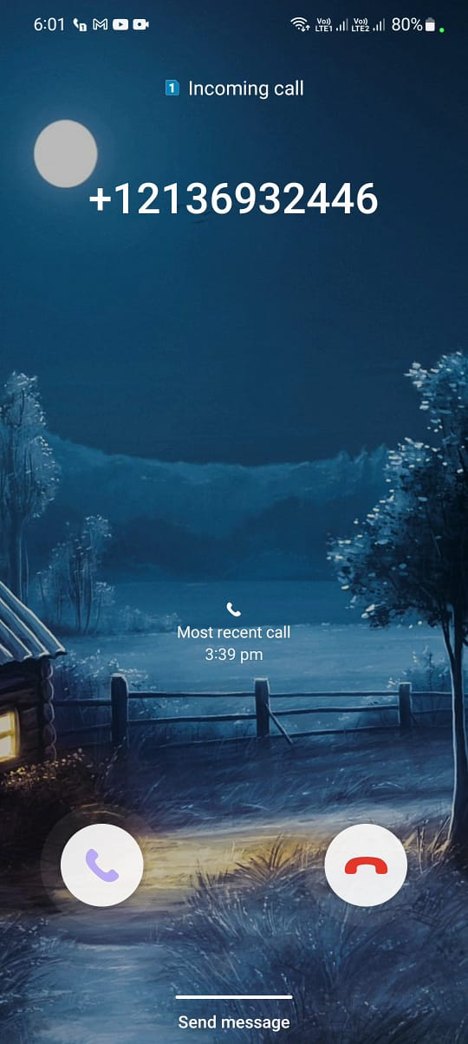


Alert
Message
from
your
Child

